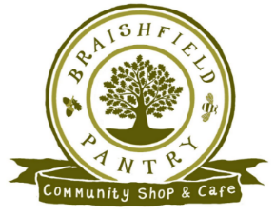Braishfield Pantry

Review Feb 2016 – Mar 2017

**Overview**

This review covers the 14month period from February 1st 2016 to March 31st 2017. In this time, the Pantry has established itself as a viable and respected service that is valued by the community.

Average sales per day of £271 compared to £218 in the 12-month period Feb 2015 – Jan 2016 and approximately 260 transactions per week demonstrate the usage. We continue to see people meeting in the Pantry on a regular basis and are attracting more and more cyclists and walkers. However, the mainstay is the regular customers who continue to use the Pantry for both convenience foods as well as the more distinct local produce. The Community focus of the Pantry has also been seen in the work with Eastleigh College and the support provided to their Business students as well as the opportunities to provide work experience to local youngsters completing their Duke of Edinburgh awards.

Outside of the village, the Pantry was recognised twice; chosen as a finalist in the Rural Enterprise section of the 2016 Campaign to Protect Rural England (CPRE) Hampshire Countryside Awards and winning the Best Independent Food Shop of the year from Hampshire Life. We also conducted visits/meetings with other Community Shops and had the Plunkett Foundation provide an independent “health check” on the Pantry’s operation which was positive.

Our Volunteers remain integral to the success of the Pantry and we now have 55 volunteers who continue to give their time and energy and the Committee would like to thank everyone for their contribution, whether it be serving visitors or the myriad of other tasks that need to be done to keep the Pantry operational.

A lot of work has been done behind the scenes to establish processes and procedures for improved food hygiene standards, financial control, stock management, general administration and both seeking out new local suppliers and maintaining positive relationships with existing suppliers. These are all essential features of running an efficient small business and our appreciation goes to the “Unsung Heroes” who provide their time and effort to undertake all these essential tasks.

**Financial Performance**

A Summary of our Profit & Loss Accounts (Fig.1) shows that while our Sales and Trading Profit have increased significantly over the 14 months our net profit is only £404.

|  |  |  |
| --- | --- | --- |
| Fig 1. Summary of P&L | Feb 16 – Mar 17 | Feb 15 – Jan 16 |
| Sales | £80047 | £48631 |
| Direct Expenses | £55420 | £35128 |
| Gross Profit | £24627 | £13503 |
| Overheads | £20564 | £11039 |
| Trading Profit | £4063 | £2466 |
| Depreciation | £3659 |  |
| Net Profit | £404 | £2466 |

However, the Net Profit figure does not tell the full story as the Pantry now, quite rightly, absorbs the full cost of electricity. Depreciation was not factored into last year’s accounts and the full impact of depreciation since the start of the Pantry in 2014 has had to be reflected in the 2016-2017 figures.

Taking this into account, a more accurate comparison of the financial performance is in Fig 2 and shows an adjusted loss of £568 compared to an adjusted profit of £1733.

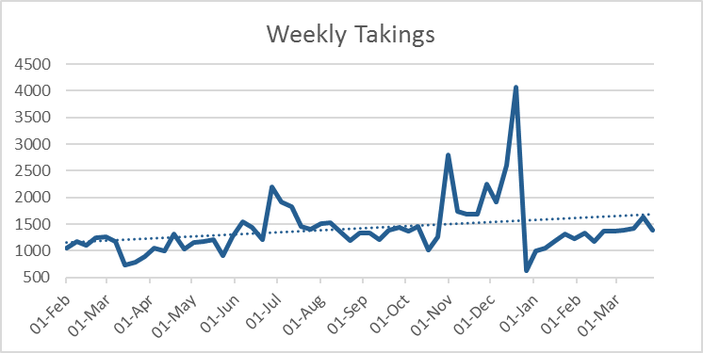Importantly, weekly takings grew steadily in the period. They have plateaued at around £1300 for a “normal” week and we have based the April 2017 -18 budget on this number.

**Volunteers**

In the period 55 different people have volunteered to support the Pantry in some way with an average of 30 volunteers each month. The actual number of volunteers has grown each quarter with the vast majority of these volunteers giving their time to serving behind the counter. We do have many activities that help in other ways and are always looking out for more support.

Two training sessions were run in the year one on Food Handling & Cleaning and the other on Alcohol and Allergen Awareness with two other events run to update and thank volunteers.

**Governance**

The Committee has met regularly throughout 2016 to oversee the running of the Pantry. A key focus on the later part of the year has been the need to move to become an Independent Trading Company. This is now near to completion and from June the Pantry will be owned by the Village Hall but managed by 4 Directors of the Trading Company.

We completed a review of our Operating Manual and asked two members of the Community to provide an Independent review of our procedures to ensure we were actually doing what we say we should be doing. Both felt the Pantry was being well run, but did provide some very useful feedback on where we could improve things.

**Services**

|  |  |
| --- | --- |
| Product | % of GP |
| Wine | 5.6% |
| Soft Drinks | 4.8% |
| Eggs | 4.0% |
| Fish | 3.9% |
| Meat | 3.6% |
| Biscuits | 3.2% |
| Ice Cream | 3.0% |
| Christmas Products | 2.9% |
| Sweets | 2.6% |
| Crisp Nuts & Snacks | 1.7% |
| Milk & Yoghurt | 1.5% |
| Bread | 1.5% |
| Cheese | 1.3% |
| Tea/Coffee | 1.0% |

The Pantry is a blend of distinct local products, convenience store and a cafe focussing on Home Baking. Based on data over the past 14 months we estimate that circa 50% of our Gross Profit comes from café sales and 50% from shop sales.

We started to open on Wednesday mornings from June and changed the opening times in the afternoons so we are now open from 2pm to 5pm and have supported a number of local events: Hampshire Village Hall Conference, Braishfield 5-mile Race, European elections, Jubilee Celebrations, Local MP Surgery and BVA Christmas carols.

In addition, we have hosted two wine tasting events, as well as a cooking demonstration (Canapes for Christmas). These events are very popular and are both important sources of revenue and a means of attracting new customers which will be developed in 2017-18.

We have grown our products from 279 items to 615 and have 30 local suppliers. The “product mix” between convenience and distinct local products appears to be well balanced, albeit it is the more distinct products e.g. Trout Pate, Roy Hunt Pies and Broughton Buffalo that are best sellers.

**Prices**

Our aim is to be be reasonably priced compared to local supermarkets. Against a basket of 15 products the Pantry is within 5% of Sainsbury’s at Badger’s Farm and 4% of Waitrose in Romsey. However, when one adds travel cost the Pantry works out cheaper than both.



(Notes: Comparison made on March 13th

Travel is based on mileage from centre of Braishfield, petrol at £1.20 p/lt and average MPG of 35.)

**Marketing**

The Pantry now has a website, Facebook Page and Twitter Account. The website is not heavily used but Twitter and Facebook are becoming useful tools to stay connected with suppliers. We have established an email distribution list but this is still in its infancy and we still rely heavily on word of mouth and posters around the village.

Marketing is one area where we recognise more could be done and greater expertise and time is perhaps required to fully develop the Pantry

**Premises**

We moved into the new extension in February 2016 and have continued to develop the facilities:

* A new store room and volunteer toilet were finished
* New shelving was installed
* New seating for both indoors and outdoors was purchased
* Air – conditioning was added
* New Chillers were purchased in March

We will continually look to utilise space in 2017 and have recognised the need for better product display which we aim to develop in 2017.

**Key Performance Indicators**

|  |  |  |  |  |  |  |  |
| --- | --- | --- | --- | --- | --- | --- | --- |
|  |  |  | Actuals Feb 16 -Mar 17 | | | | |
| Indicator | Target | 2015 | Q1 | Q2 | Q3 | Q4 | Feb/Mar |
| Sales per day | £242 | £218 | **£240** | **£252** | **£246** | **£276** | **£271** |
| Margin | 30% | 27% | **29%** | **32%** | **32%** | **30%** | **30%** |
| Trading Profit | £1874 | £2458 | **£-346** | **£1742** | **£2645** | **£3704** | **£4063** |
| Number of Volunteers | 50 | - | **-** | **45** | **47** | **55** | **55** |
| Current Assets (less liabilities) | £6500 | £5676 | £3694 | **£6037** | **£7679** | **£9162** | **£6633** |
| Total Assets (less liabilities) | £7500 | £6792 | £6446 | **£9104** | **£10927** | **£7539** | **£7898** |
| No of Products held | 350 | 280 | **349** | **378** | **520** | **615** | **615** |
| No of local Suppliers | 30 | 17 | **22** | **27** | **28** | **30** | **30** |
| No of visitors per week | 250 | Not known | Not Known | **266** | **240** | **280** | **-** |
| No of hits on the website per month | 100 | - | **-** | **270** | **439** | **564** | **640** |
| No of positive comments | 3 per month | Not known | **19** | **13** | **13** | **13** |  |

Notes: No of volunteers is measured by the active volunteers who have worked in the shop or who are relied on for other support in that quarter.

No of visitors per month is based on a sample of one week every month (to start in Q2)